**C_Basic_Assignment_1**

**ARR/01 Display an array/or a subset of the array. The function accepts the array, the number of elements to display. It displays the elements each on one line and returns void.**

**Ans:**

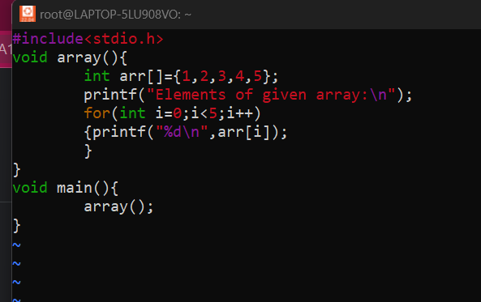

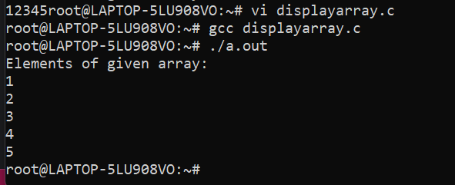

**ARR/02 Accept array elemnents from user. The function parameters are the array, the number of elements to enter and the maximum size of the array. It returns the number of elements accepted. The input array is also populated with the element**

**Ans:**

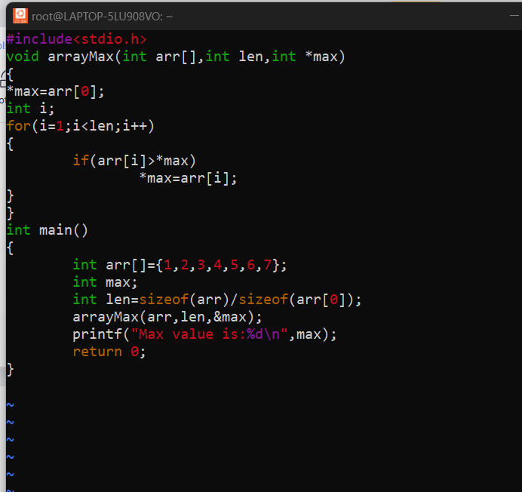

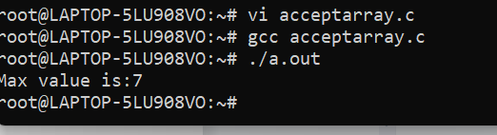

**ARR/03 Returns the sum of the maximum and minimum element of the array.**

**Ans:**

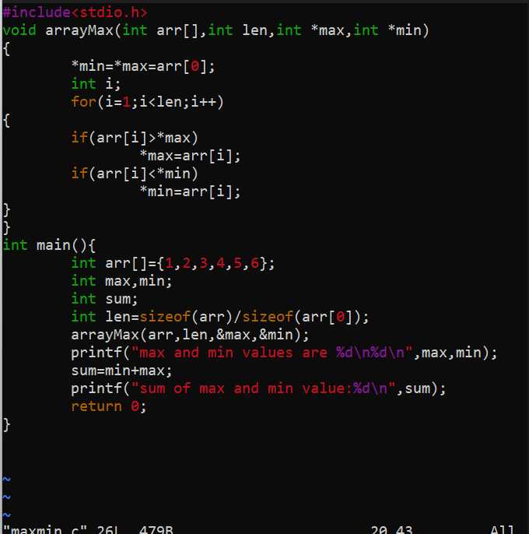

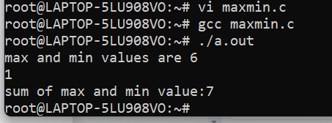

**ARR/04 Count for the number of occurences of a particular element in an array.**

**Ans:**

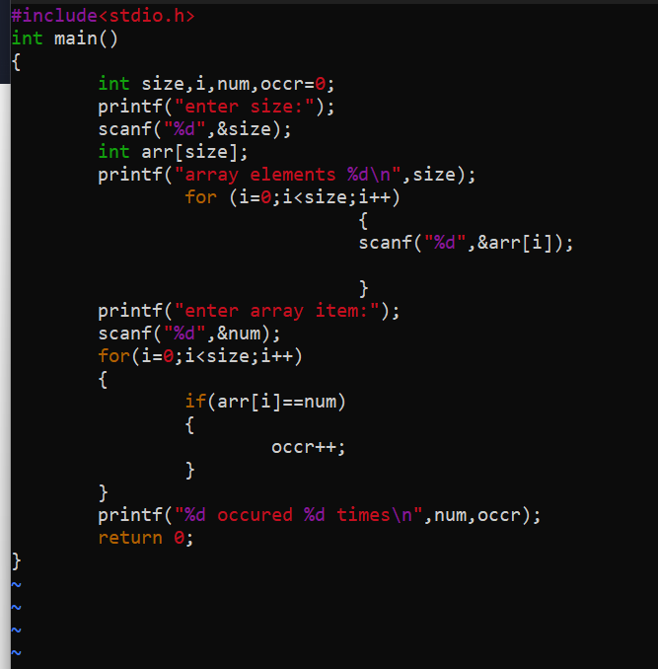

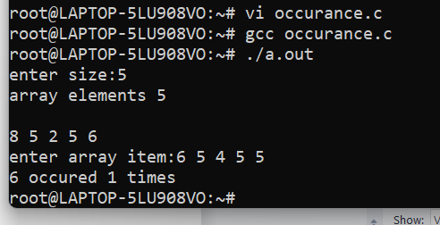

**ARR/05 Reverse the contents of the array. If initially the array contains 10, 5, 6, 7 then after reversal the contents will be 7, 6, 5, 10. Do not use any intermediate array**

Ans:

